Title: | AEP QRO.  Window Lifter
Authors: Habib Alejandro Apez González.
Estefanía López Villagómez.

History
Issue status  (Index) | Maturity/Date  (draft/invalid/valid)  (dd-mmm-yyyy) | Author  Department | Check/Release  Department | Description
5.0 | Draft  28-0ct-17 | Habib Alejandro  Apez González.  Estefanía  López Villagómez. | Continental Engeeniers. | Window Lifter is a project than simulates the behavior of an operational car window.  This one shalls do the up and down movement of the window at the user will prefer with the use of a simple interface based in some buttons and a light system to show us the action.

Table of Contents
1 Purpose 3
2 Definitions and abbreviations 3
3 Realization constraints and targets 3
4 SW Conceptual design 3
5 SW Component internal breakdown 4
5.1 Functional Decomposition 4
5.2 Function <Type> <function name> (type par 1, .., type par n) 5
5.3 Function <Type> <function name> (type par 1, .., type par n) 5

Purpose

A power window lifter is an automobile part which can be manipulated to up or down and other specific safety use control.

This project will work using two push buttons, one for the up movement, and the other one to down, these specific buttons are going to order to our product to simulate the window movement represented with a ten segment red light bar, this light will turn on to be a complete close window or turn off to get down as the user will wanted.

Each button have two modes, normal and one touch. The first one works to make all the track if you press for determinate time, and the second one is for only a part of the track with a quick movement.

There is to an extra function: Anti pinch this is a safety requirement than works only when the up movement is activated to prevent some kind of accidents, this stops the other move and make than our window down completely and remain stop for 5 seconds. Then our normal process continues.

The process our all the functions are scheduled in layers: MAL, HAL, APP. To simplify the final operations and delimit the functions with the option to continue adding other future operations.

- MCAL

IO  - GPIO  - PORT A  - PORT B  - PORT C  - PORT D  - PORT E  - PDOR  - PSOR  - PCOR  - PTOR  - PDIR  - PDDR  - PIDR | LPIT  - PCC_LPIT  - VERID  - PARAM  - MCR  - MSR  - MIER  - SETTEN  - CLRTEN  - RESERVED_0  - TVAL  - CVAL  - TCTRL  - TMR[LPIT_TMR_COUNT]
PCC  - PCC_PCCn_COUNT  - PCC_FTFC_INDEX  - PCC_DMAMUX_INDEX  - PCC_FlexCAN0_INDEX  - PCC_FlexCAN1_INDEX  - PCC_FTM3_INDEX  - PCC_ADC1_INDEX  - PCC_FlexCAN2_INDEX  - PCC_LPSPI0_INDEX  - PCC_LPSPI1_INDEX  - PCC_LPSPI2_INDEX  - PCC_PDB1_INDEX  - PCC_CRC_INDEX  - PCC_PDB0_INDEX  - PCC_LPIT_INDEX  - PCC_FTM0_INDEX  - PCC_FTM1_INDEX  - PCC_FTM2_INDEX  - PCC_ADC0_INDEX  - PCC_RTC_INDEX  - PCC_LPTMR0_INDEX  - PCC_PORTA_INDEX  - PCC_PORTB_INDEX  - PCC_PORTC_INDEX  - PCC_PORTD_INDEX  - PCC_PORTE_INDEX  - PCC_FlexIO_INDEX  - PCC_EWM_INDEX  - PCC_LPI2C0_INDEX  - PCC_LPUART0_INDEX  - PCC_LPUART1_INDEX | PORT  - PCR[PORT_PCR_COUNT]  - GPCLR  - GPCHR  - GICLR  - GICHR  - ISFR  - RESERVED_1[28]  - DFER  - DFCR  - S_PORT
SCG  - SCG  - VERID  - PARAM  - RESERVED_0[8]  - CSR  - RCCR  - VCCR  - HCCR  - CLKOUTCNFG  - RESERVED_1[220]  - CLKOUTCNFG  - RESERVED_1[220]  - SOSCCSR  - SOSCDIV  - SOSCCFG  - RESERVED_2[244]  - SIRCCSR  - SIRCDIV  - SIRCCFG  - RESERVED_3[244]  - FIRCCSR  - FIRCDIV  - FIRCCFG  - RESERVED_4[756]  - SPLLCSR  - SPLLDIV  - SPLLCFG  - S_SCG | WDT  - Watch dog  - CS  - CNT  - TOVAL  - WIN  - S_WDT

- HAL

Clock  - Init_Clock | Button  - Init_Buttons  - ButtonUp_Press  - ButtonDown_Press  - ButtonAntipinch_Press  - Init_Buttons  - ButtonUp_Valid_Debounce  - ButtonDown_Valid_Debounce  - ButtonAntipinch_Valid_Debounce
Leds  - Turn_On_UpLED //Blue one  - Turn_On_DownLED //Green one  - Turn_On_AntipinchLED //Red one  - Turn_Off_UpLED //Blue one  - Turn_Off_DownLED //Green one  - Turn_Off_AntipinchLED //Red one  - Init_Leds //Bar led | Timmer  - Init_Timer  - Wait_50ms  - Wait_400ms  - Wait_450ms  Wait_5s
Segmentbar

- Init_Bar ( )
- Set_Level_Bar ( )

- APP
BarButton  - Barrido  - Main  + Button | WindowLifter  - UpNormal  - DownNormal  - OneTouchUp  - OneTouchDown  - Antipinch  - Main  + Clock  + Buttons  + Leds  + Bar  + Timer

Definitions and abbreviations
Definitions
GPIO | General-Purpose Input/Output
LPIT | Low-power Programmable Interrupt Timer
PCC | Peripheral Clock Controller
PORT | Port Control and Interrupts

Abbreviations
Only SW Component specific abbreviations.
References
N° | Document name | Reference
1 | Window lifter requirements.docx | Continental
2 | V_Cycle Process | Continental
3 | V_Cycle Process Script.xlsx | Continental
4 | S32K1xx Series Reference Manual | NXP
5 | Naming Conventions.pdf | Continental
6 | https://www.iar.com/iar-embedded-workbench | IAR
7 | MISRA C:2012 March 2013 | Continental
8 | S32K1xx Data sheet | NXP

Realization constraints and targets

Window Lifter

The principal purpose is controlling a simulation window movement.

It will going to work with the interface of 3 different buttons, one will do the action to up, the other one will do the down and an extra will do the Antipinch mode.

There is going to be appreciable de action using a light to indicate it, blue to Up, Green to Down.

One restriction of the requirements is than this project only can have a ten segment bar led to simulate the movement.

Other restriction is the use of the board S32K144EVB-Q100.

SW Conceptual design

General window lifter system, it specifies the actions of the application with the interaction of the buttons and the corresponding light to the action they will going to do: Up, Down and Antipinch, to can make than the window shows.

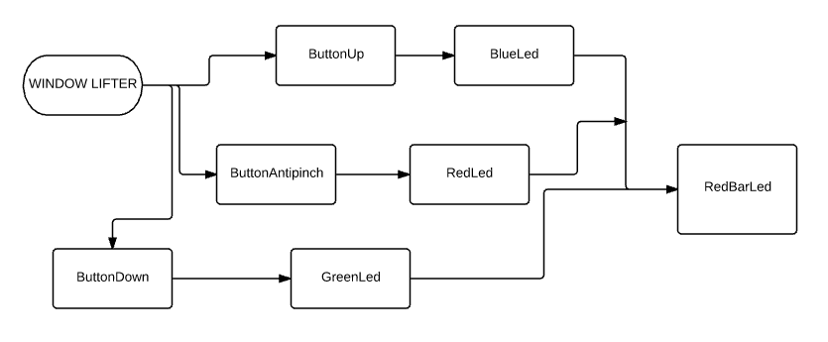

Diagrama Esquemático

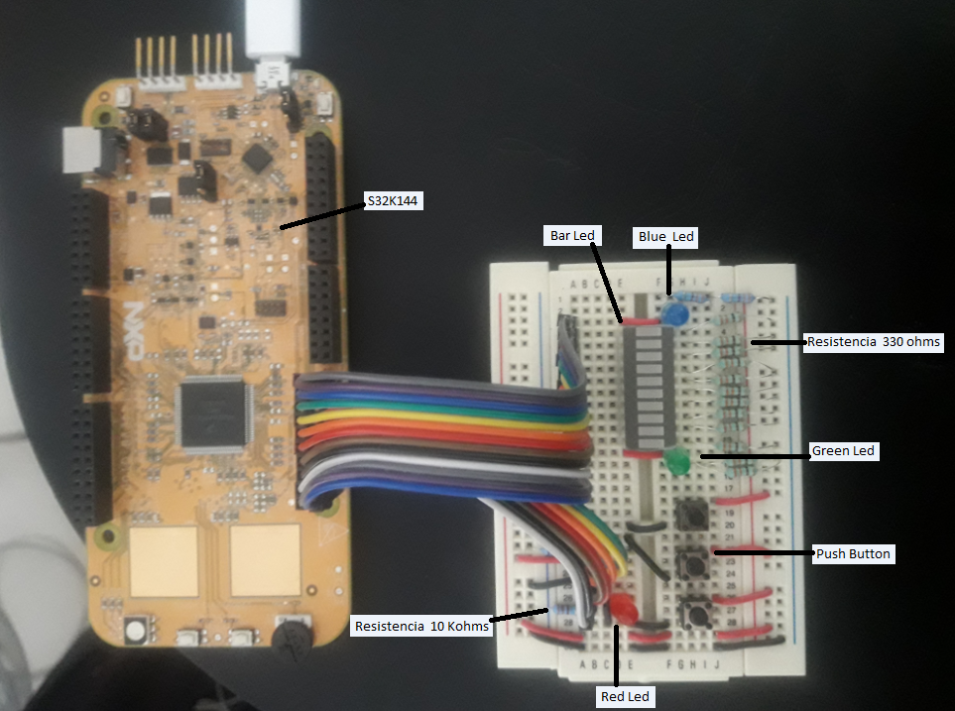

SW Component internal breakdown
For complex SW Components, the designer may define SW Subcomponents. Please consider also the work step "Deal with complexity" provided by the method for Detailed SW Design.
Note: SW Subcomponents are synonymous with the previous used term "Module"
Mapping to the file structure:
- Non complex SW Components should be represented by one object file.
- For complex SW Components each SW Subcomponent should be represented by one object file.
<Subcomponent decomposition if applicable>

****Descripcion de la function a donde pertenece
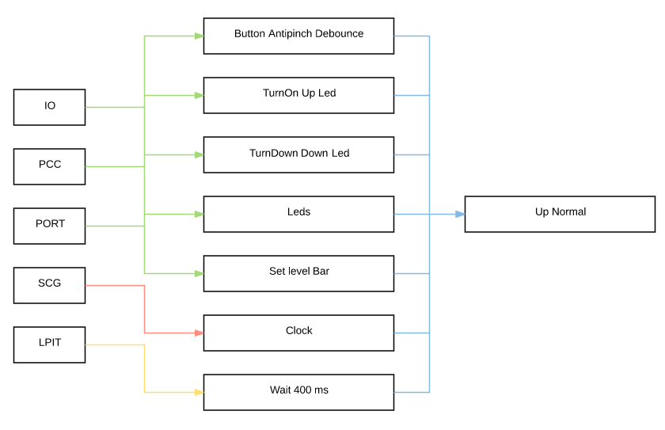

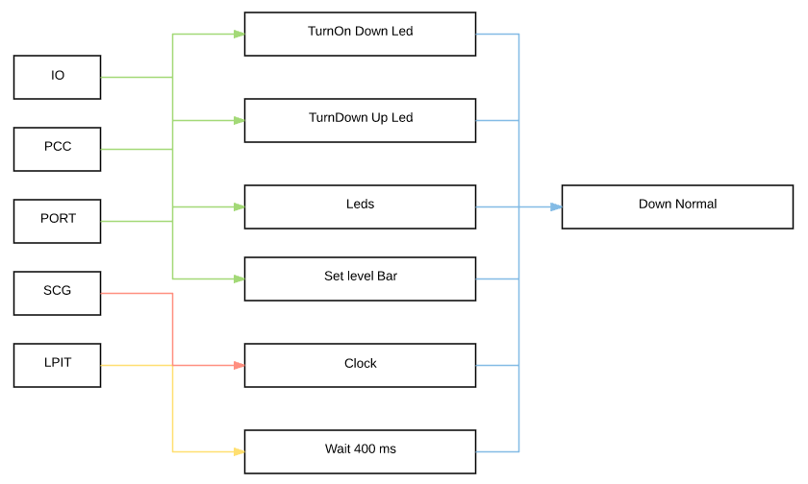

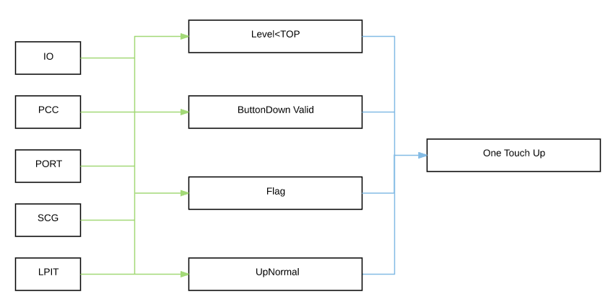

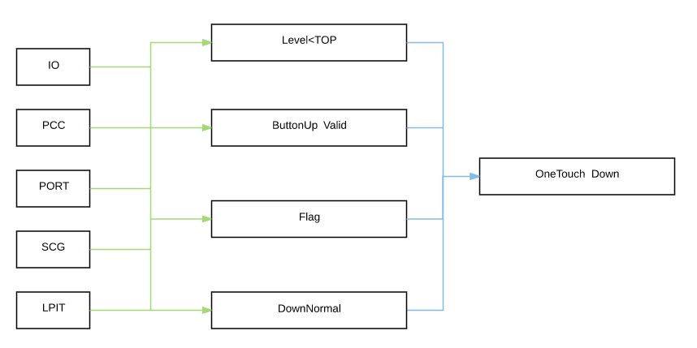

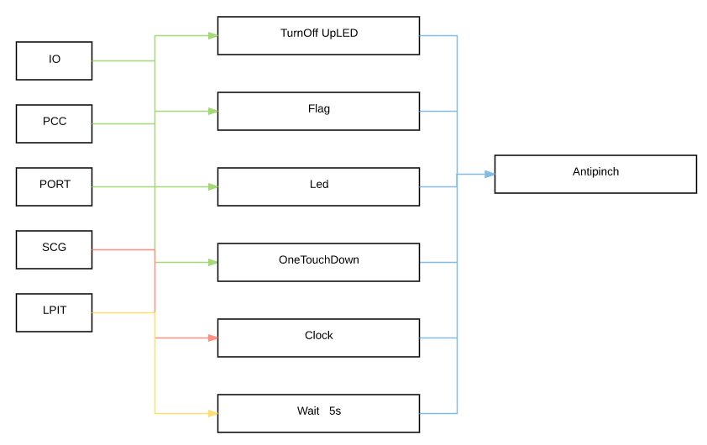

Functional Decomposition
Overview of functions and their dependencies shown by a Static Function Tree
Pngo la function y la descripcion de la function en lo que hace
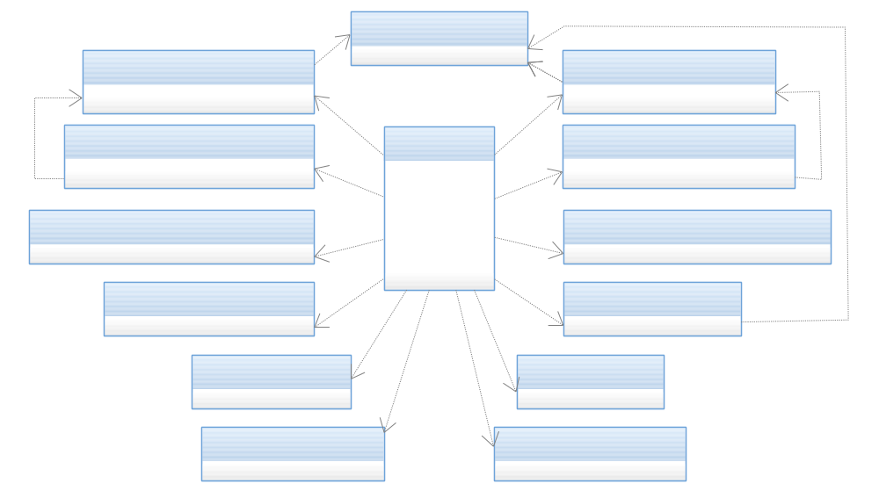

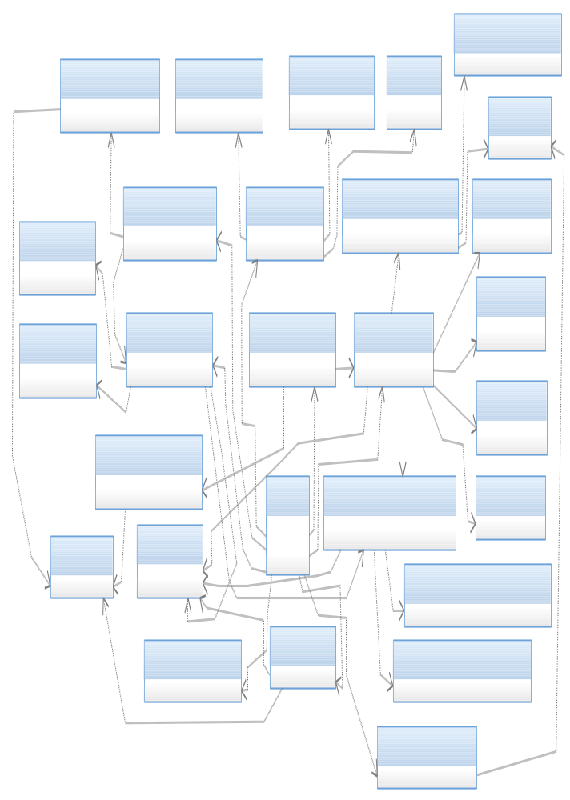
Function Description and Dynamic Behavior

Function

Dynamic Behavior
State Chart¹, Flow Chart¹
¹ Preferred
In this document, the dynamic behavior shall be designed on an abstract level showing the principle workflow of a function. Do not show the detailed implementation to ensure that the design description can be maintained with a reasonable effort. The target is not to show the complete detailed implementation 1:1.
The detailed design shall reflect in detail what a function is doing from a black box view. The internal details are useful on an abstract, but not very detailed level.
If the function is not complex a short textual description might be sufficient and a graphical description is not needed.
Symbol and function names shall be self explaining.
The link to the implementation may be provided by using the same names as in the design or by a comment showing the full name followed by the declaration showing the implementation

HAL

Button.c

- Void button_InitButtons(void)

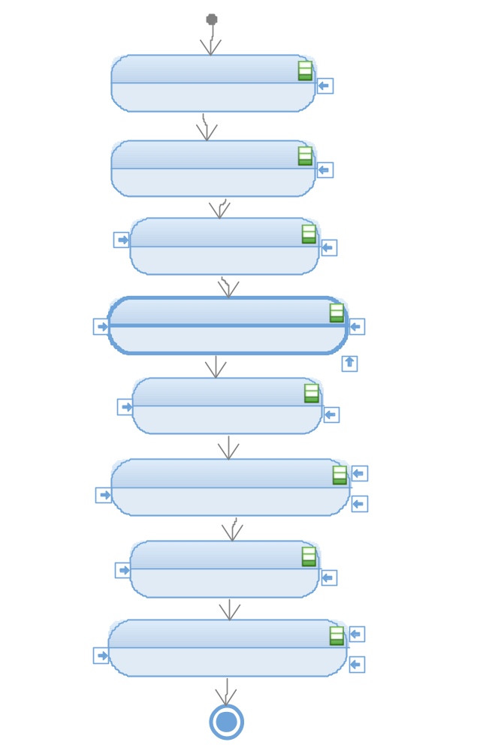

Description | This function enables the specific pins in the ports to make them inputs, this are going represent the three button actions (UpButton, DownButton, AntipinchButton)
Parameter 1 | There is not a parameter in this function.
Parameter 2 | ----
Return Value | Returns void
Precondition | Not preconditions, but the PCC.C .library must be include
Post condition | The pins now have the new register so then the buttons are fuctional.
Error Conditions | ----

///////////////////////////////////////////////////////////////////////////////////////////////////////////////7

- Function T_UBYTE button_CheckButtonUp(void);

Description | Checks the state of the Pin 5 of the Port E configured as input.
Parameter 1 | None
Return Value | Returns void
Precondition | The pin must have been configured as an input.
Post condition | The state (high 1 or low 0) should be returned.
Error Conditions | None

Dynamic Behavior
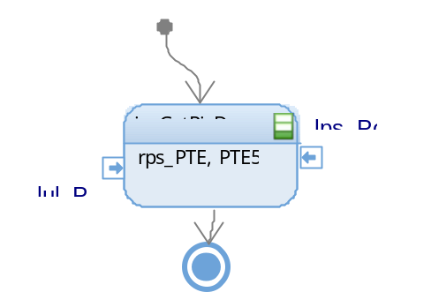

- Function T_UBYTE button_CheckButtonDown(void);

Description | Checks the state of the Pin 12 of the Port A configured as input.
Parameter 1 | None
Return Value | Returns void
Precondition | The pin must have been configured as an input.
Post condition | The state (high 1 or low 0) should be returned.
Error Conditions | None

Dynamic Behavior
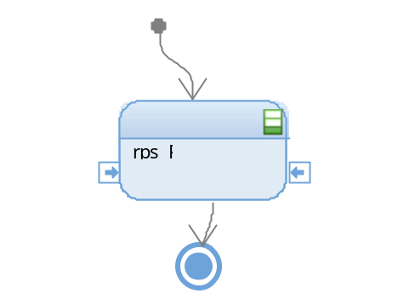
- Function T_UBYTE button_CheckButtonAntipinch (void);

Description | Checks the state of the Pin 13 of the Port A configured as input.
Parameter 1 | None
Return Value | Returns void
Precondition | The pin must have been configured as an input.
Post condition | The state (high 1 or low 0) should be returned.
Error Conditions | None

Dynamic Behavior
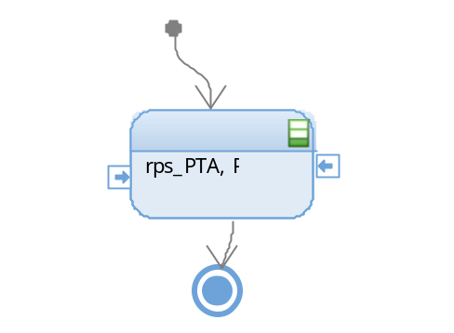

- Function T_UBYTE button_DebounceButtonUp (void);

Description | Reads the input of the Up button, then waits 50ms and then reads it once again to be sure that it is a valid press ant not a debounce.
Parameter 1 | None
Return Value | Returns void
Precondition | The pin must have been configured as an input.
Post condition | Returns 1 if the press is valid and 0 if it is not valid.
Error Conditions | None

Dynamic Behavior
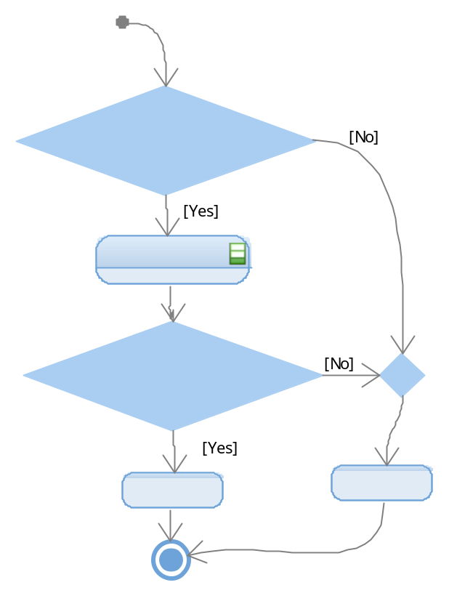

- Function T_UBYTE button_DebounceButtonDown (void);

Description | Reads the input of the Down button, then waits 50ms and then reads it once again to be sure that it is a valid press ant not a debounce.
Parameter 1 | None
Return Value | Returns void
Precondition | The pin must have been configured as an input.
Post condition | Returns 1 if the press is valid and 0 if it is not valid.
Error Conditions | None

Dynamic Behavior
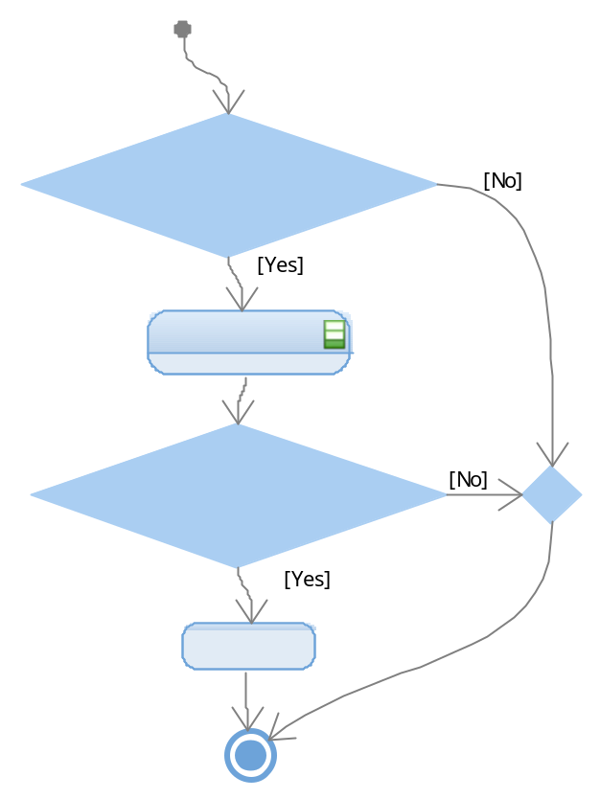

- Function T_UBYTE button_DebounceButtonAntipinch (void);

Description | Reads the input of the Antipinch button, then waits 50ms and then reads it once again to be sure that it is a valid press ant not a debounce.
Parameter 1 | None
Return Value | Returns void
Precondition | The pin must have been configured as an input.
Post condition | Returns 1 if the press is valid and 0 if it is not valid.
Error Conditions | None

Dynamic Behavior
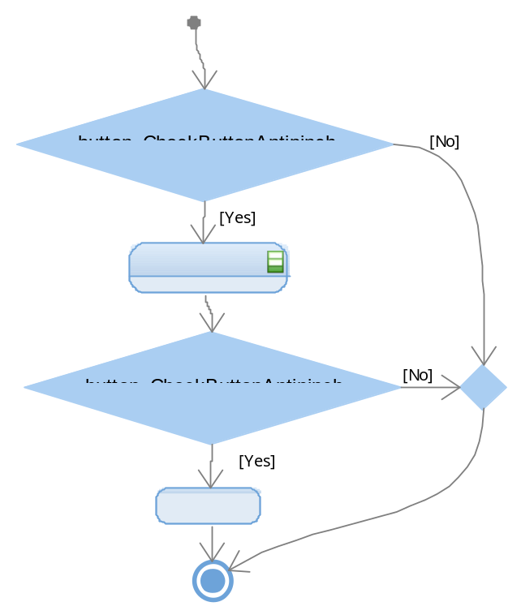

Clock

- Function Void clock_InitClock (void);

Description | Initializes the System Clock, the PLL and configures the Run mode of the system oscillator.
Parameter 1 | None
Return Value | Returns void
Precondition | None
Post condition | The system clock is initialized.
Error Conditions | None

Dynamic Behavior
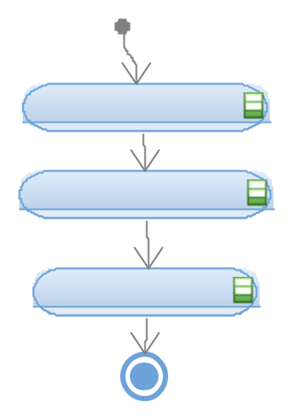

Leds
- Function Void leds_InitLeds(void);

Description | Configures the Pin 13 of the PortA (Up LED), the Pin 5 of the PortE (Down LED)Down and the Pin 12 of the PortA (Antipinch LED) as outputs.
Parameter 1 | None
Return Value | Returns void
Precondition | The clock of the Port A and E should have been initialized.
Post condition | The outputs of those pins are set low.
Error Conditions | None

Dynamic Behavior
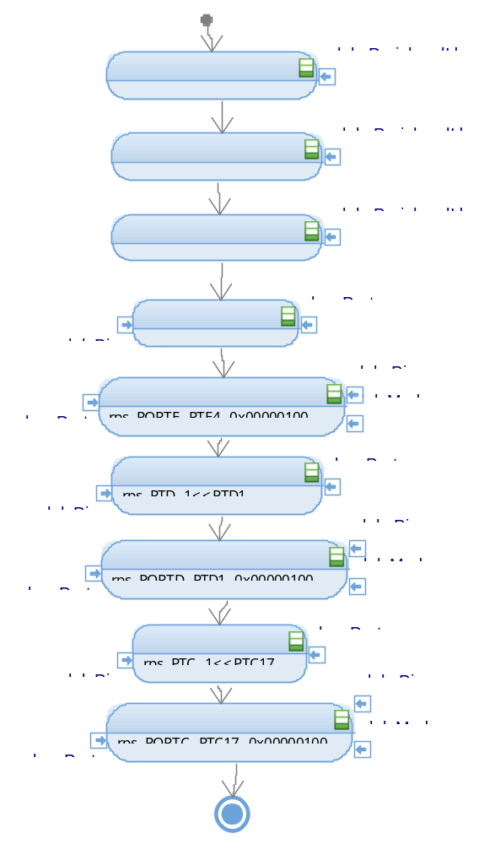

- Function Void leds_TurnOnUpLed (void);

Description | Sets high the output of the Up LED located at Pin 4 of the PortE
Parameter 1 | None
Return Value | Returns void
Precondition | The Pin should have been initialized as an output
Post condition | There is a high voltage level at the pin.
Error Conditions | None

Dynamic Behavior
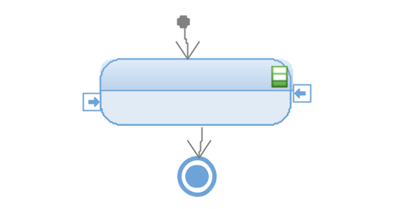

- Function Void leds_TurnOnDownLed (void);

Description | Sets high the output of the Up LED located at Pin1 of the PortD
Parameter 1 | None
Return Value | Returns void
Precondition | The Pin should have been initialized as an output
Post condition | There is a high voltage level at the pin.
Error Conditions | None

Dynamic Behavior
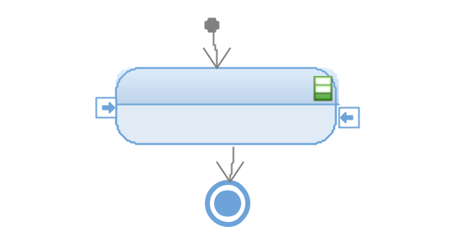

- Function Void leds_TurnOnAntipinchLed (void);

Description | Sets high the output of the Up LED located at Pin17 of the PortC
Parameter 1 | None
Return Value | Returns void
Precondition | The Pin should have been initialized as an output
Post condition | There is a high voltage level at the pin.
Error Conditions | None

Dynamic Behavior

- Function Void leds_TurnOffUpLed (void)

Description | Sets low the output of the Up LED located at Pin17 of the PortC
Parameter 1 | None
Return Value | Returns void
Precondition | The Pin should have been initialized as an output
Post condition | There is a low voltage level at the pin.
Error Conditions | None

Dynamic Behavior
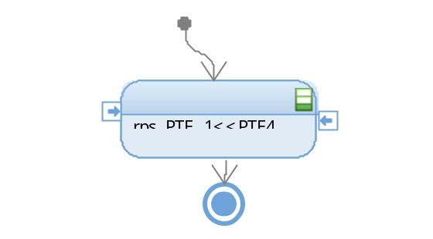
- Function Void leds_TurnOffDownLed (void)

Description | Sets low the output of the Up LED located at Pin1 of the PortD
Parameter 1 | None
Return Value | Returns void
Precondition | The Pin should have been initialized as an output
Post condition | There is a low voltage level at the pin.
Error Conditions | None

Dynamic Behavior
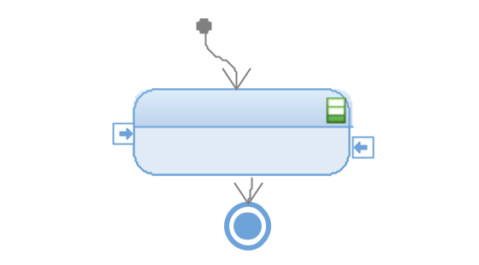

- Function Void leds_TurnOffAntipinchLed (void)

Description | Sets high the output of the Up LED located at Pin17 of the PortC
Parameter 1 | None
Return Value | Returns void
Precondition | The Pin should have been initialized as an output
Post condition | There is a high voltage level at the pin.
Error Conditions | None

Dynamic Behavior
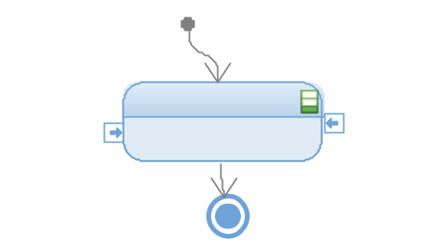
////////////////////////////////////////////////////////////////////////////////////////////////////////////////////////////////////////////

Segmentbar

- Void segmentbar_InitBar (void)
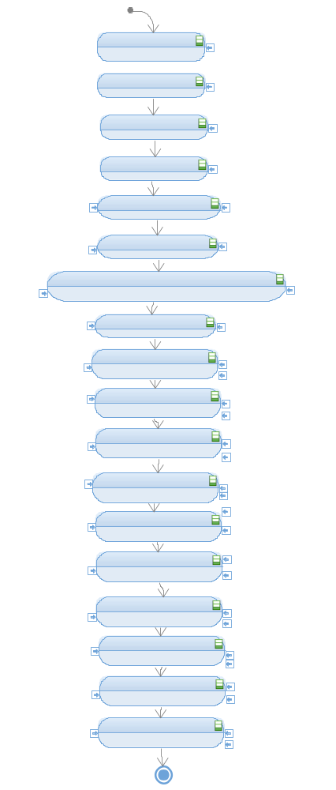
Description | Brief description of the function behavior and useful remarks
Parameter 1  <input| output| inout> | Give an explanation if the parameter shall be checked by the user, or if a check is implemented in the function here
Parameter 2..n
Return Value
Precondition | e.g. Function can only be called in a certain state, SW component is initialized  Relation between input parameters where applicable (Input for Module Test)
Post condition | e.g. specific State change e.g. car is locked, EEPROM Values written,  Relation between output parameters where applicable
Error Conditions

- Void segment_SetLevelBar (T_UBYTE lub_level)
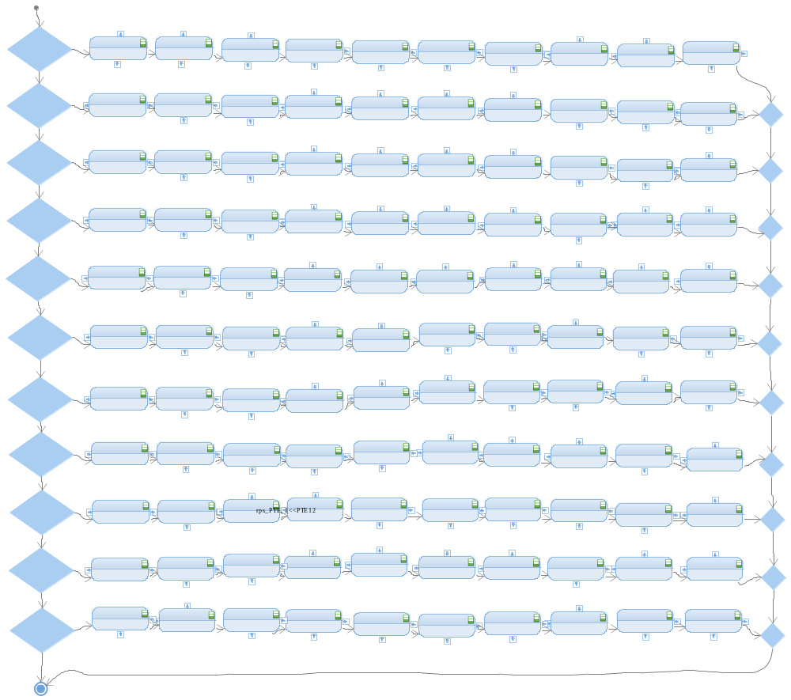

Description | Brief description of the function behavior and useful remarks
Parameter 1  <input| output| inout> | Give an explanation if the parameter shall be checked by the user, or if a check is implemented in the function here
Parameter 2..n
Return Value
Precondition | e.g. Function can only be called in a certain state, SW component is initialized  Relation between input parameters where applicable (Input for Module Test)
Post condition | e.g. specific State change e.g. car is locked, EEPROM Values written,  Relation between output parameters where applicable
Error Conditions

Timer

- Void timer_InitTimer (void)

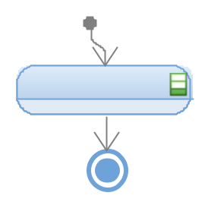

Description | Brief description of the function behavior and useful remarks
Parameter 1  <input| output| inout> | Give an explanation if the parameter shall be checked by the user, or if a check is implemented in the function here
Parameter 2..n
Return Value
Precondition | e.g. Function can only be called in a certain state, SW component is initialized  Relation between input parameters where applicable (Input for Module Test)
Post condition | e.g. specific State change e.g. car is locked, EEPROM Values written,  Relation between output parameters where applicable
Error Conditions

////////////////////////////////////////////////////////////////////////////////////////////////////////////////////////////////////////////////
- Function Void timer_Wait50ms (void)

Description | Delays during 50ms. Uses the channel 0 of Low Power Interrupt Timer to implement the delay. Charges the delay value, enables the timer and wait until it completes the count, then clean the interrupt flag and disable the timer.
Parameter 1 | None
Return Value | Returns void
Precondition | System Clock and Low Power Interrupt Timer must have been configured.
Post condition | None
Error Conditions | None

Dynamic Behavior
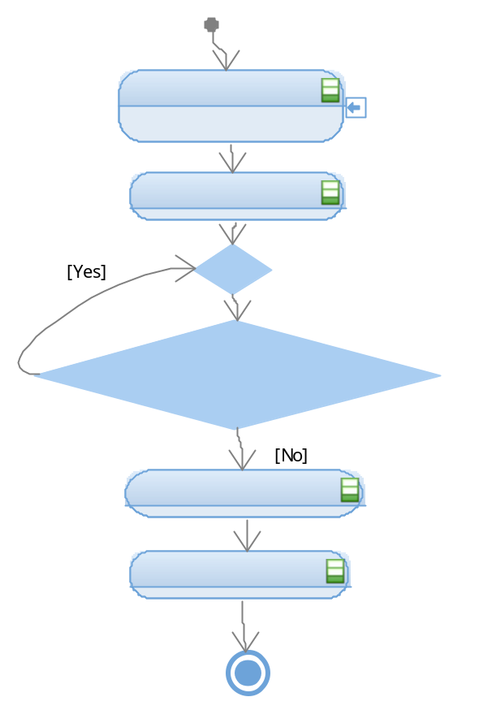
- Function Void timer_Wait400ms (void)

Description | Delays during 50ms. Uses the channel 0 of Low Power Interrupt Timer to implement the delay. Charges the delay value, enables the timer and wait until it completes the count, then clean the interrupt flag and disable the timer.
Parameter 1 | None
Return Value | Returns void
Precondition | System Clock and Low Power Interrupt Timer must have been configured.
Post condition | None
Error Conditions | None

Dynamic Behavior
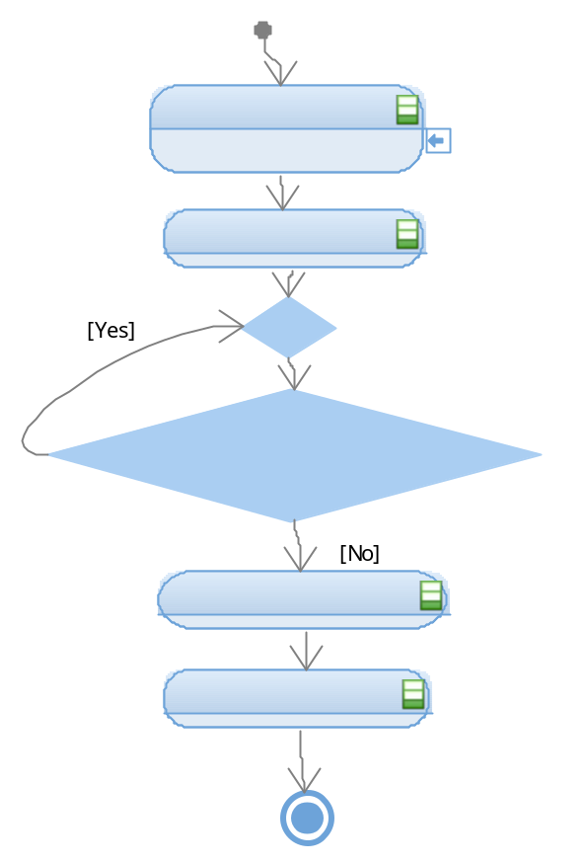

- Function Void timer_Wait450ms(void)

Description | Delays during 450ms. Call to timer_Wait400ms(void) and then timer_Wait50ms(void).
Parameter 1 | None
Return Value | Returns void
Precondition | System Clock and Low Power Interrupt Timer must have been configured.
Post condition | None
Error Conditions | None

Dynamic Behavior
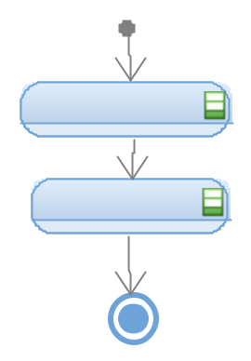

- Function Void timer_Wait5s (void)
Description | Delays during 5s. Uses the channel 0 of Low Power Interrupt Timer to implement the delay. Charges the delay value, enables the timer and wait until it completes the count, then clean the interrupt flag and disable the timer.
Parameter 1 | None
Return Value | Returns void
Precondition | System Clock and Low Power Interrupt Timer must have been configured.
Post condition | None
Error Conditions | None

Dynamic Behavior
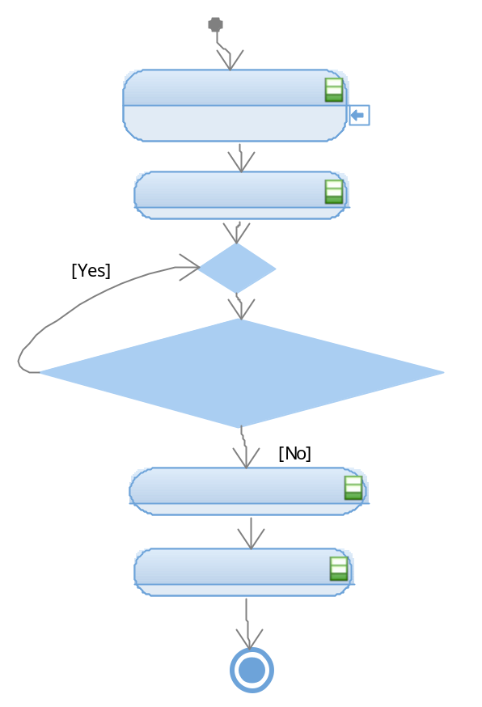
App

Windowlifter

- Void windowlifter_Antipinch(void);
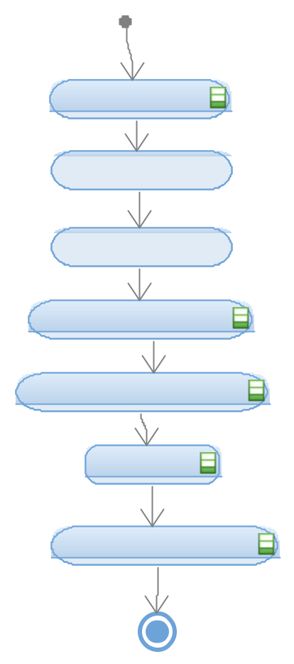

Description | Brief description of the function behavior and useful remarks
Parameter 1  <input| output| inout> | Give an explanation if the parameter shall be checked by the user, or if a check is implemented in the function here
Parameter 2..n
Return Value
Precondition | e.g. Function can only be called in a certain state, SW component is initialized  Relation between input parameters where applicable (Input for Module Test)
Post condition | e.g. specific State change e.g. car is locked, EEPROM Values written,  Relation between output parameters where applicable
Error Conditions

- Void windowlifter_UpNormal (void);
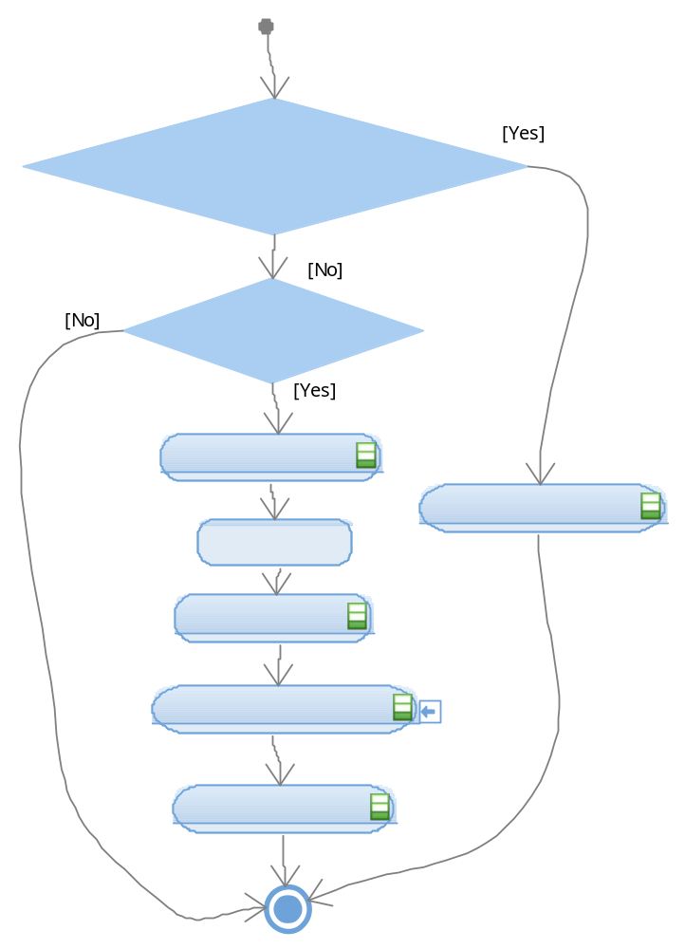

Description | Brief description of the function behavior and useful remarks
Parameter 1  <input| output| inout> | Give an explanation if the parameter shall be checked by the user, or if a check is implemented in the function here
Parameter 2..n
Return Value
Precondition | e.g. Function can only be called in a certain state, SW component is initialized  Relation between input parameters where applicable (Input for Module Test)
Post condition | e.g. specific State change e.g. car is locked, EEPROM Values written,  Relation between output parameters where applicable
Error Conditions

- Void windowlifter_DownNormal (void);

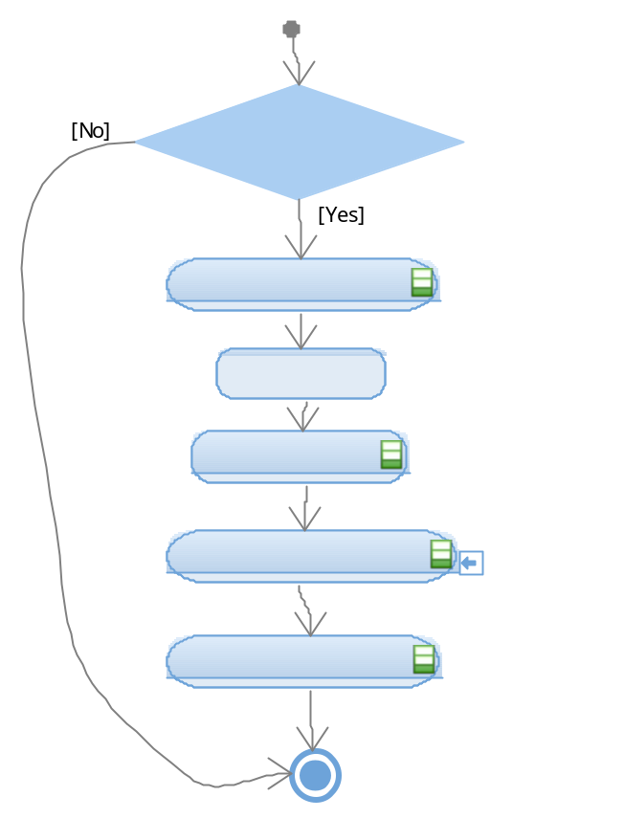

.
Description | Brief description of the function behavior and useful remarks
Parameter 1
<input| output| inout>
Parameter 2..n
Return Value
Precondition | e.g. Function can only be called in a certain state, SW component is initialized  Relation between input parameters where applicable (Input for Module Test)
Post condition | e.g. specific State change e.g. car is locked, EEPROM Values written,  Relation between output parameters where applicable
Error Conditions

Description | Brief description of the function behavior and useful remarks
Parameter 1
<input| output| inout>
Parameter 2..n
Return Value
Precondition | e.g. Function can only be called in a certain state, SW component is initialized  Relation between input parameters where applicable (Input for Module Test)
Post condition | e.g. specific State change e.g. car is locked, EEPROM Values written,  Relation between output parameters where applicable
Error Conditions

- Void windowlifter_OneTouchUp (void);
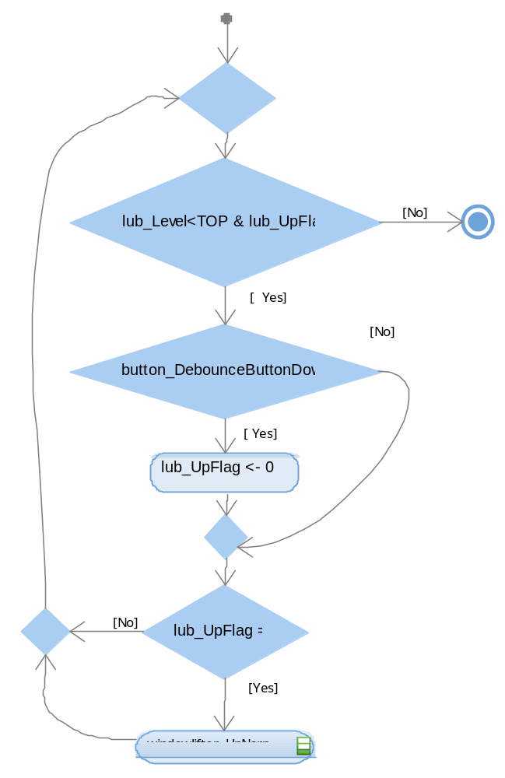
Description | Brief description of the function behavior and useful remarks
Parameter 1
<input| output| inout>
Parameter 2..n
Return Value
Precondition | e.g. Function can only be called in a certain state, SW component is initialized  Relation between input parameters where applicable (Input for Module Test)
Post condition | e.g. specific State change e.g. car is locked, EEPROM Values written,  Relation between output parameters where applicable
Error Conditions

- Void windowlifter_OneTouchDown(void);
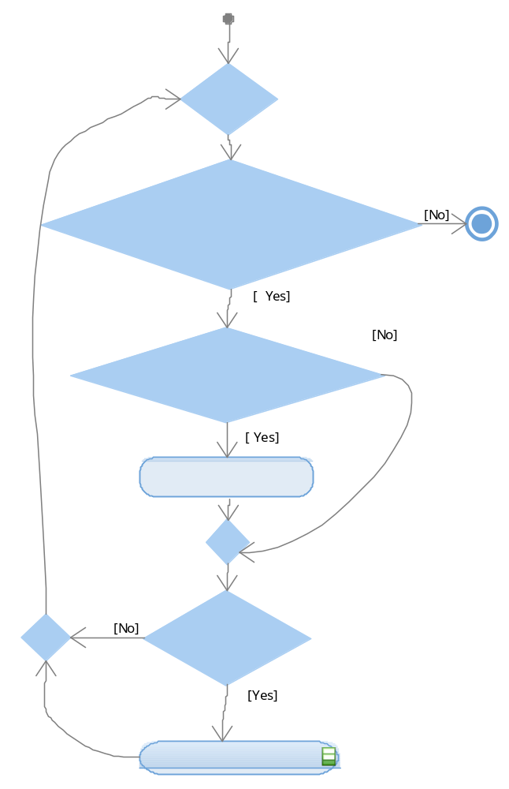

Description | Brief description of the function behavior and useful remarks
Parameter 1
<input| output| inout>
Parameter 2..n
Return Value
Precondition | e.g. Function can only be called in a certain state, SW component is initialized  Relation between input parameters where applicable (Input for Module Test)
Post condition | e.g. specific State change e.g. car is locked, EEPROM Values written,  Relation between output parameters where applicable
Error Conditions

- Void main (void);
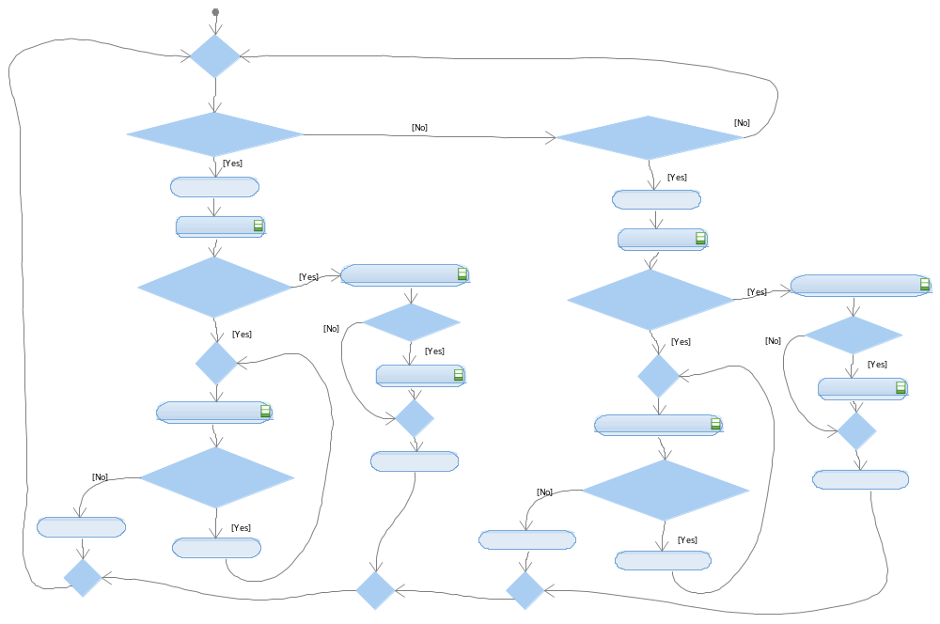

Description | Brief description of the function behavior and useful remarks
Parameter 1
<input| output| inout>
Parameter 2..n
Return Value
Precondition | e.g. Function can only be called in a certain state, SW component is initialized  Relation between input parameters where applicable (Input for Module Test)
Post condition | e.g. specific State change e.g. car is locked, EEPROM Values written,  Relation between output parameters where applicable
Error Conditions

